Greater Victoria Collation to End Homelessness

An INSPIRE Project: Final Report

**Submitted to**

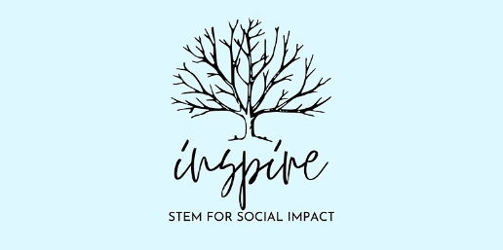

**Submitted by**

Ahmed Momoh (V00882348)

Bachan Ghimire (V00996378)

Mobina Rafieipour (V00931526)

Parker DeBruyne (V00837207)

**17th August 2022.**

Table of Contents

Introduction and Background 4

Inspire UVIC 4

Greater Victoria Collation to End Homelessness 4

The Problem 5

The Team 5

Research 5

Past Research 5

Literature Reviews 6

Interviews 7

Data Analysis 7

Focus Group 9

Validation 9

Solution Development 10

Requirements Engineering 10

Epic: Women+ Navigator Dashboard 10

Epic: Shelter Administrators 11

Epic: Super Admin 11

Dev-Operations & Management Approach 12

Iterations 12

Remote Git Repository 13

Knowledge Management 13

Development Approach 14

Relational Model & Database 15

System Modeling 16

Code Structure 19

Deployment Architecture 20

The product 21

Shelter Administrator Pages 21

Super Administrator Pages 22

Public and Navigator Views 23

Conclusion and Future Work 24

References 25

**Table of Figures**

Figure 1: Research Design 6

Figure 2: Interview Analysis Sample 7

Figure 3: Feature Identification Process 8

Figure 4: Requirements Backlog Design (Microsoft DevOps Documentation, 2022) 10

Figure 5: Public Dashboard: Epic & Features 10

Figure 6: Epic & Features: Organization Portal 11

Figure 7: Epic & Features: Super Admin 11

Figure 8: Azure DevOps Dashboard 12

Figure 9: Iteration Plans 12

Figure 10: Project Repository 13

Figure 11: Azure Wikis for Knowledge Management 13

Figure 12: Software as a Service (Cloudfare.com) 14

Figure 13: Development Stack & MVVM Code Pattern 14

Figure 14: Entity Relationship Diagram (ERD) of the Database 15

Figure 15: Use Case Diagram of GVCEH Housing Portal 16

Figure 16: Context Diagram of the Software 17

Figure 17: GVCEH Housing Portal Structure Chart 18

Figure 18: Sample RazorPages Architecture 19

Figure 19: Azure Deployment Architecture (Microsoft Azure CI/CD documentation) 20

Figure 20: Shelter Admin Dashboard 21

Figure 21: Shelter Admin Housing Features 21

Figure 22: SuperAdmin Dashboard 22

Figure 23: SuperAdmin Organization Management 22

Figure 24: Public Live Housing Feed 23

Figure 25: Housing Details 23

# Introduction and Background

The Greater Victoria Coalition to End Homelessness (GVCEH) needs an easily accessible way for women+, who are at risk of violence and homelessness, to learn about and access safe and appropriate housing, supports, and services. This led to a collaboration between our Inspire team and the Coalition to begin the process of ideation to come up with a feasible solution. Dr. Michelle Vanchu-Orosco of the Coalition, suggested the idea of the women+ (those who identify as women) fleeing violence navigator web and mobile application, based on research she helped facilitate with two Geography and Environmental studies students at the University of Victoria, Dufort and Lando.

These applications are intended to provide a single platform to learn about/access all services in the Greater Victoria region that would be of use to a woman+ (an individual who identifies as a woman) who is at risk of violence and/or homelessness. It would also be beneficial to organizations and front-line workers who support these women. The application would provide sources of basic services, like food and housing, to more specific resources like peer support groups for women+ who have experienced gender-based violence, including intimate partner violence. The team spent the past few months completing various tasks for the deployment of the software, and we now have a live and fully functioning web application, although not all features have been implemented at this instance.

The purpose of this report is to highlight the progress made towards developing these applications over a four-month period and provide some insight on work to be done in the future.

## Inspire UVIC

Inspire is a program of research and community-based innovation at the University of Victoria, that helps to facilitate mentorship for students with industry professionals and the community to ideate and co-create solutions that address society’s most pressing challenges, especially around sustainability.

## Greater Victoria Collation to End Homelessness

The Greater Victoria Coalition to End Homelessness (the Coalition) is an organization that was formed in 2008 and has taken up the mantle as a driving force in the challenging mission to end homelessness in the capital region. The Coalition comprises local housing, health, and social service providers; non-profit organizations; all levels of government; businesses; the faith community; people with a lived experience of homelessness (past or present); and members of the public. They are a diverse membership and they convene to address the needs of individuals experiencing homelessness in the capital region.

Their mission is to ensure appropriate solutions are in place to serve those individuals experiencing homelessness in the capital region, and to ensure all people facing homelessness in the capital region have access to safe, affordable, appropriate, long-term housing.

Dr. Michelle Vanchu-Orosco was our Community Partner with the Coalition and introduced the Inspire team to the project. She helped facilitate our research; got us connected with health and social service providers (support workers); provided invaluable input to the solution development process; and contributed immensely to the successful completion of the project in its entirety.

## The Problem

The Inspire team identified that women+ fleeing domestic violence do not know where to go next because there is no coordinated resource system, and lapses in communication between shelters serving individuals experiencing homelessness does not help in alleviating the problem. The goal is to help facilitate the Coalition in coming up with an effective and functional way to tackle this problem through participatory engagement and community collaboration.

## The Team

The apprentice garage team was composed of four team members and an ambassador to help oversee the flow and progress of the project:

* + Payton Chernoff
    - Ambassador
    - Recent UVic graduate of Mechanical Engineering
  + Ahmed Bello Momoh
    - Developer and Documentation
    - 4th year Mechanical Engineering student
  + Bachan Ghimire
    - Tech Lead and Project Management
    - Masters in Computer Science
  + Mobina Rafieipour
    - Research and Analysis
    - 3rd year Biomedical Engineering student
  + Parker DeBruyne
    - Outreach and Design
    - 2nd year Computer Science and Statistics student

More information on the team can be found on the Inspire project website at [inspireuvic.org](https://www.inspireuvic.org/gvceh)/gvceh.

# Research

“Homeless” is often used as a catchall term; a misnomer that brings attention to only one aspect of an individual’s or family’s predicament: namely, the lack of a roof [1]. The issue of homelessness stems from a more complex, often interconnecting set of occurrences that can require people to have to choose between shelter, food, and other necessities. After several weeks spent brainstorming and pivoting through prospective approaches on how to critically go about finding a potential solution for women+ fleeing intimate partner violence to access resources available to them, the team began approaching support workers, shelter providers, and individuals with lived experience of homelessness. We quickly realized that shelter providers have no effective communication system between them, and to better serve women+ fleeing violence, such a system needs to be in place. The team decided to indirectly help these women by providing a system for support workers to better optimize certain aspects of their daily job routine. This led to the idea of creating a web application that shelters across Victoria can log into and update the number of spaces they have available for women seeking shelter.

## Past Research

The bedrock of the research conducted by Dufort and Lando was to collaborate between researchers and community members, creating a level ground for each group to contribute and provide invaluable insight to the project. They conducted a focus group that consisted of women+ with clear objectives to identify what type of resources women+ in fleeing violence, possibly at risk of homelessness, need, and what resources currently exist that help meet the needs of women+ fleeing violence in the Greater Victoria region. The resources needed by women+ and available in Victoria could be divided into three categories of distinct themes: necessities, trauma support, and emergency response. Based on the preliminary findings from the research done by Dufort and Lando, we made the initial assumption of building an application to be primarily used by women+ fleeing violence or at risk of homelessness. We took this idea and began the process of exploring the functionality and feasibility of building such an application. The findings from the research conducted by Dufort and Lando, two Geography and Environmental studies majors at the University of Victoria served as the fundamental block in informing our research procedures. They engaged in a Community-Based Participatory Research (CBPR), with the goal to understand and explore the deficiencies involved in traditional research methods.

This research was a part of a Geography project course that provided an opportunity for the students to work alongside the Coalition in tackling a project that contributed to real change, with emphasis on community collaboration.

## Literature Reviews

To provide a viable solution for our community partner and the Coalition, we spent several weeks going through different research methodologies in gathering information to help the brainstorming phase of our project. Due to the complexity of the issues surrounding women+ fleeing violence and in danger of homelessness, having different approaches to identifying a potential solution(s) to these problems was very crucial to the success of the team’s ideation process. “Qualitative research with its exploratory focus leaves a lingering sentiment that there are words left unsaid-unable to be reached” [2]. This inspired the team to approach the research phase in a more creative way, through a participatory based approach in which interviews and other research methodologies were structured in a way to engage participants in the form of open discussion [3].

The goal of the community-based participatory research approach is to create a process that will increase collaboration between researchers and the communities that they study [4]. This method provides equal grounds for sharing knowledge and resources to meet communal goals that benefits all participants. CBPR aims to foster research that leads to actual social change [5]. We found this method to be extremely effective as we were able to extract vital pieces of information by allowing participants to share their stories and experience. This approach enabled us to identify individual pain points, different user personas, and create empathy maps to suit each persona.

Figure 1: Research Design

## Interviews

After doing the literature review and envisioning fleeing from violence by making a user journey map, we decided to continue our investigations by interviewing people with lived experiences and social workers. In total, we interviewed eight people in a semi-structured format. Interviews took place in a different timeline of the project and were analyzed in detail in order to refine the problem statement and ensure that the product of this project will be positively impactful on women+ fleeing from domestic violence.

## Data Analysis

When an interview was conducted, we went over the recorded scripts and extracted “pain points”, which are challenges in the daily life of social workers, and areas where technological might be useful. The pain points became the starting topics for future interviews, and future interviews were used to confirm or deny our assumptions of what needed to be built. Ultimately, we did find that technology could be used to make their work easier. We also designed surveys and did more literature reviews to confirm our findings. The following figure explains our approach to analyzing the collected data and brainstorming for the next measure needed to be taken.

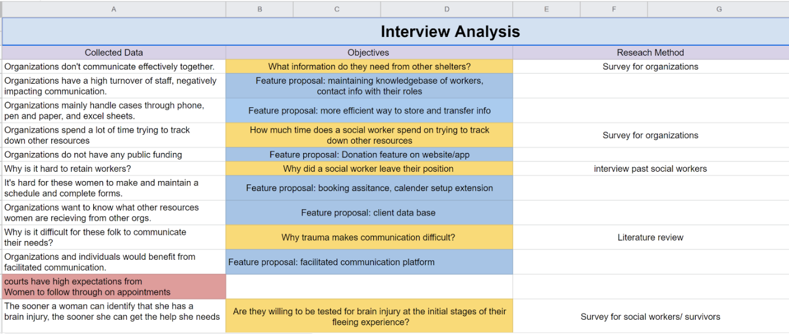

Figure 2: Interview Analysis Sample

Our analysis made us realize that in order to help women+ fleeing domestic violence, we would need to give the social workers in the filed improved systems of technology. All the shelters interviewed in Victoria are facing high levels of staff burnout and turnover. It costs them a considerable amount of time to hiring and training new staff, and before new social workers can get used to their responsibilities, they quit. Non-profit organizations and charities are usually tight on their budgets, so this could be a considered a large area of financial loss. This information led us to another question: why is there a high staff turnover rate among social workers?

To validate our assumptions and find an answer to this question, we interviewed four workers from different shelters such as The Cridge Center for The Family, and Peers. Interviewing social workers from organizations that aim to assist varied populations in Victoria gave us the opportunity to gain a broad perspective of the challenges they encounter. After analyzing the scripts once again, we realized that the following pain points are commonly mentioned among people working in shelters and non-profit organizations:

* Their workload is high, and they need to deal with stressful situations.
* Navigation of resources and finding the right resource for their clients is challenging.
* They need to spend considerable amounts of their time calling other organizations to get updates on resource availability and sleeping arrangements.

Therefore, our final problem statement is *“Women+ fleeing from domestic violence have difficulties finding where to go, because the is no coordinated resource system.”*

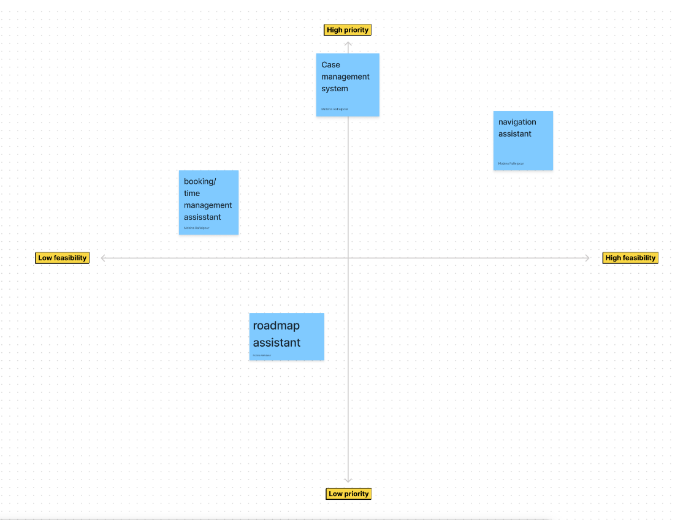

Figure 3: Feature Identification Process

To identify the best solution, we grouped features to include in an app or website by what was needed vs what was feasible to build. In addition, by using a prioritization matrix, we decided to work on a navigation assistant. In a prioritization matrix, the option that is in the top left side of the chart is the best decision considering the circumstances. Meanwhile, our user requirements illustrated that our community partner was not willing to take legal responsibilities for managing the collection of personal data. Data privacy and cyber security were their main concerns. Consequently, this constraint lowered the feasibility of designing a booking and assistant management system in this project’s scope. Overall, the resource navigation system was the most feasible and had a high priority.

## Focus Group

During the development phase, we took advantage of a focus group to get the input of social workers, researchers, and the indigenous community to align our product with their needs. The main takeaways from this focus group were:

* Shelters do not only provide beds, but they also provide spaces with rooms and mats.
* It sometimes takes more than 24 hours to secure a spot in a shelter.
* There is a possibility to sign up once for more than one night in some of the shelters, which indicates that the working style of the shelters is different and women facing homelessness expressed confusion and being overwhelmed by that.
* Women+ fleeing from domestic violence, need a more facilitated system to sign up for the shelter's waitlists.

## Validation

A high staff turnover rate is a common problem in most shelters and support centers that assist women plus fleeing from domestic violence. Social workers identified their role to be overwhelming especially for new staff. Realizing that women+ fleeing from domestic violence might not know of our service to use once they flee their homes, indicated that it is possible to put them in touch with the resource navigator once they contact one of the support centers.

At this stage, we needed to narrow down our problem for a minimum viable product (MVP). We realized that women+ would be less likely to use other services unless they are housed. Therefore, emergency housing is the initial resource we focused on. We aimed to facilitate acquiring information from emergency housing organizations such as shelters. Moreover, we realized that there is a need for a platform where various organizations would communicate and share their up-to-date information and the services they provide. While social workers expressed the need to call other organizations for updates on their availabilities and waitlists, our brainstorming session, using user journey and prioritization matrices led us to our initial design.

# Solution Development

Upon validation of our high-level features from the research and focus group, we began planning on solution development. It was apparent that a web application was needed, as our primary user target would be the administrators in the shelters.

In order to facilitate communication between shelters, we designed an application that would show live availability of beds in different shelters. On this application, shelters would be able to maintain and update their availabilities, contact information, and eligibility requirements. Meanwhile, women+ fleeing from domestic violence could use this website to get regular pieces information and updates on all the shelters. All the shelters and their performance will be managed by a super administrator organization, which is currently owned by GVCEH. Overall, this website could be used by three different users:

* Super Administrator
* Shelter admins
* Public (women+ fleeing from domestic violence, and people who seek new updates)

While we have launched our first MVP, we realized this is just the beginning of the journey of this project. There is a lot of room for enhancement in the design and development of this website to make it more interactive and effectively responsive.

## Requirements Engineering

We began by identifying Epics in the highest level of requirements breakdown. We categorized features per epic and created user stories for each feature, as in classic scrum software development approach. While most of the epics, features and stories were managed by the technical lead, the tasks were autonomously managed by team members.

Figure 4: Requirements Backlog Design (Microsoft DevOps Documentation, 2022)

### Epic: Women+ Navigator Dashboard

Primarily, the navigator page we wanted to create for women+ fleeing voilence, and anybody trying to help these people out, was labelled as the “Women+ Navigator”. Within this epic, we built features such as the live housing availability feed (with housing contact, address, and features), contact forms, and lists of available resources and authentication for administrators.

Figure 5: Public Dashboard: Epic & Features

### Epic: Shelter Administrators

We defined our second epic as Organization Portal, where upon logging in, the administrators of respective shelters would be able to update their housing availability from their dashboard. They would also be able to view the live housing feed to understand the availability and contact different housing directly. They would also be able to update the features available in their shelters such as facilities and permissions.

Figure 6: Epic & Features: Organization Portal

### Epic: Super Admin

Our third and one of the most important epics was the Super Admin. The features under this epic would include managerial aspects such as enrolling organizations, providing a list of categories so shelters can be filtered, a live housing feed, an internal messaging service, and an analytics dashboard.

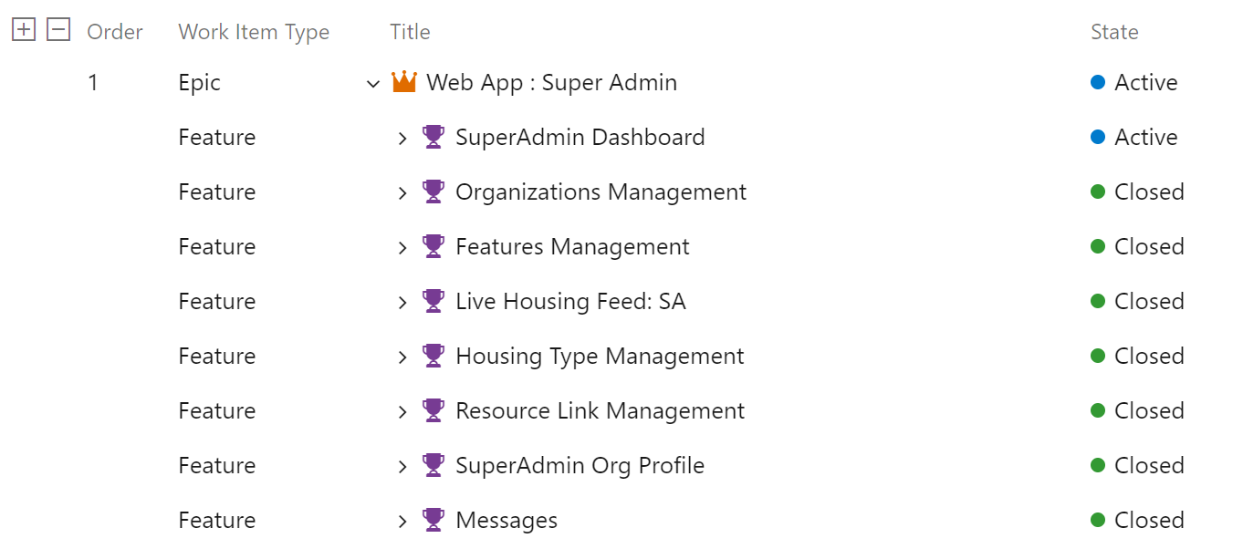

Figure 7: Epic & Features: Super Admin

## Dev-Operations & Management Approach

From a project management perspective, the project is well established as an enterprise application. As in figure 1, we created backlogs based on three levels of requirement hierarchy: Epics, Features and User Stories. The work items in this backlog would be then assigned to individuals and then would also be assigned under a sprint plan.

We used Azure DevOps for creating backlogs, iterations, Kan-ban boards, sprints, a project repository, build pipelines, and release pipelines.

Figure 8: Azure DevOps Dashboard

### Iterations

We used two-week sprint plans to define our iterations. All of the work items from the backlogs were split and were tagged with iteration plans. We conducted sprint planning meeting every other Monday and end of iterations on every other Friday.

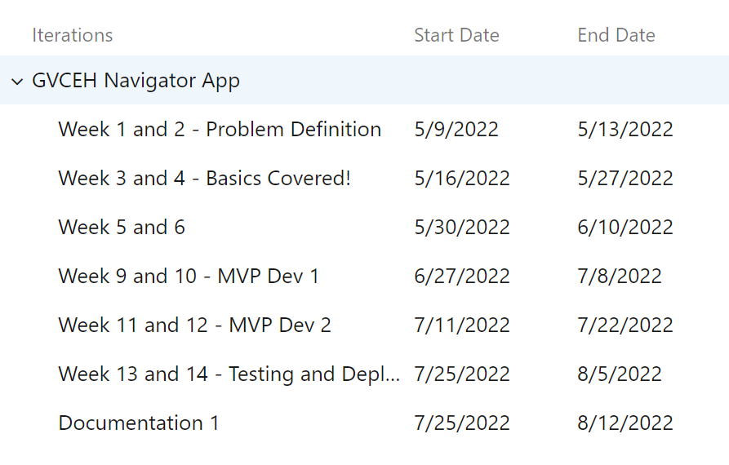

Figure 9: Iteration Plans

### Remote Git Repository

We used Azure DevOps Repos as our remote repository for version control and shared-code base. We used master and dev branches to ensure quality and prevent buggy code from being deployed.

Figure 10: Project Repository

### Knowledge Management

We used Azure DevOps Wikis for Knowledge Management. We created pages inside wiki as required to share resources and information throughout the project. An example as in figure 8, we created a page called “important links” for quick access to important URLs.

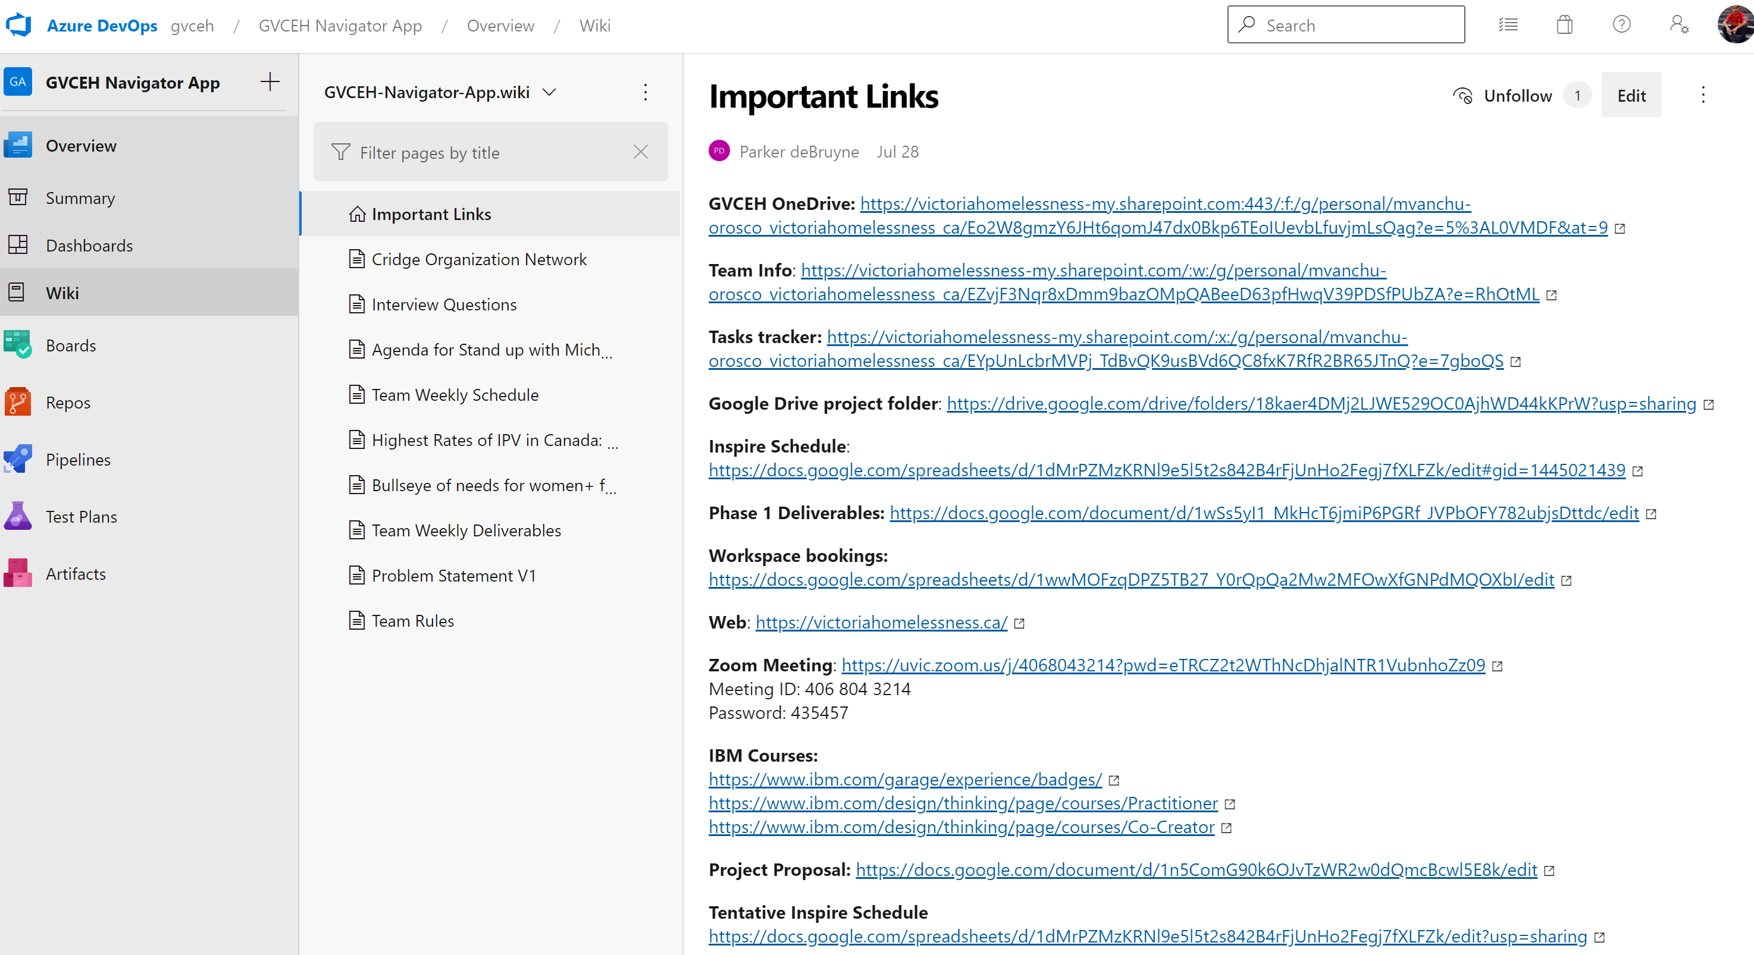

Figure 11: Azure Wikis for Knowledge Management

## Development Approach

Our development approach is the conventional Software as a Service (SAAS) approach. That is, small iterations of rolled out updates to a subscribed service as opposed to a one-time install of a large program. Unlike a typical desktop or a mobile application, this web application can be assessed on any device that supports a web browser, in any screen size. We use a mobile first approach in ensuring high quality mobile-friendly application.

While the shelters are understood to be non-profit organizations, the approach and usage of creating profiles for them inside the platform, we believe it qualifies as an SAAS approach. We built a traditional relational database to accommodate multiple dashboards and logins for same shelters.

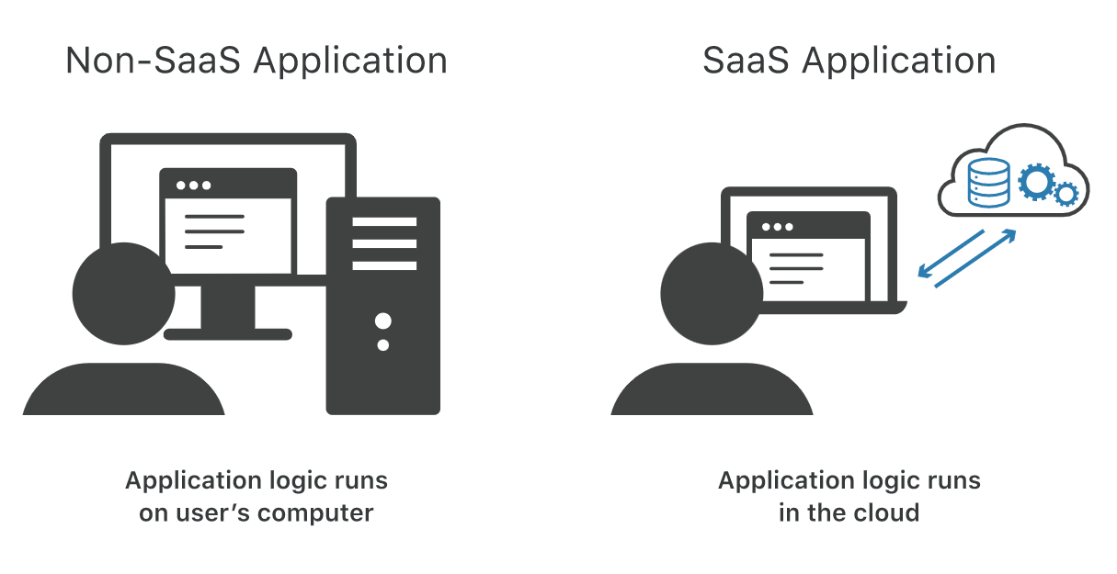

Figure 12: Software as a Service (Cloudfare.com)

We use .NET Core 6.0 as our primary development stack. .NET core is used in enterprise application development, requires high expertise to develop, is fully secure, open-source and free development library. .NET Core is written in the C# programming language and our application uses the same, as an implementation of .NET library. We use SQL Server 2012 for our database server and our application is hosted in an Azure Application Windows Server. We use .NET Core Razor Pages and bootstrap as our front-end library, written in “cshtml” and “cshtml.cs”, as a MVVM (Model View ViewModel) Architecture. We used Visual Studio as our Integrated Development Environment.

Figure 13: Development Stack & MVVM Code Pattern

## Relational Model & Database

Our database is a conventional Relational Database, which has been optimized to its third normal form (3NF): a relation is in 3NF if there is no transitive dependency for non-prime attributes as well as it is in 2NF. There are eight entities in the databases which are all related to each other. All entities have an auto-generated identifier as primary key constraints. All relationships have designated foreign-key constraints referring to its related table’s primary keys.

The primary entity ‘Housing’ stores information regarding the organizations. It has a *one-to-many* relationship with entities ‘Dashboard’ and ‘Login’, for facilitation of multiple dashboards and multiple organizational user management. Each ‘Housing’ is assigned with a field ‘HousingTypeID’ which refers to the ‘HousingType’ entity, which is a list of housing categories. The entity ‘ContactMessage’ optionally refers to ‘Housing’ depending on whether the contact was initiated from a logged in shelter administrator or from public dashboard.

Entities ‘HousingFeature’ is a bridge table between ‘Housing’ and ‘Feature’. The table ‘Feature’ is a look-up table. ‘HousingFeature’ maintains IDs of Features that are selected by each of the shelters. The decomposition of the entities was required as a result of a many-to-many relationship between features and shelters, i.e., multiple shelters can have multiple features and vice versa.

Figure 14: Entity Relationship Diagram (ERD) of the Database

## System Modeling

This phase of the Software Development Life Cycle (SDLC) is the key in providing the application a structure and defining the applicability of the application. This phase included number of approaches and methodologies. There were several UML diagrams created to facilitate development of the application. A UML diagram is a Unified Modeling Language diagram which could be of different kinds. UML diagrams are created in accordance with the need but of certain type. The types of UML diagrams that were created for this project are use case diagram, structure chart, and context diagram. All of these diagrams bring values of their own. A use case diagram shows the relation between the system and user in every term of usability, applicability, and functionality. A user, called an “actor”, inputs an action to the system. In response, the system could act back at the actor as per the requirement. The Use Case Diagram of the GVCEH Housing Portal is illustrated below.

Figure 15: Use Case Diagram of GVCEH Housing Portal

The next two diagrams are examples of a Context Diagram. The Context Diagram is a UML diagram that explains the context of the application that is being used. This diagram defines the boundary between the system, or part of a system, and its environment, showing the entities that interact with it. This diagram is a high-level view of the interaction between the existing systems.

Figure 16: Context Diagram of the Software

The four main system boundaries of the software are the web-app itself, Azure SQL Server, Cloud Application Service, and an encryption helper. As a user tries to access the software pages, they are either routed to the respective dashboards with either logged-in status or not-authorized error. The software uses a Sha2 hashing algorithm with an added salt for secure password storing. Every login and/or new account creation goes through the algorithm to verify and hash the raw string, as well as checking regular expression as needed. LINQ queries are passed onto the SQL server with a connection string, using Entity Framework. Each executed query results with a status code. As a developer commits and pushes to a master branch, the final component of the software, Azure DevOps triggers a build and release pipeline with resulting deployment.

The final UML diagram we created is called a structure chart. Structure charts assist the development phase of SDLC as it describes the structure of the program architecture. With Structure Chart, the Class Architecture and Relational Models can be derived. Structure charts can also help produce a sitemap for the server. Having several routing configurations and pages can be confusing to users as well as future developers, which is the rationalization of need for a structure chart. Our platform’s abstract structure chart and sitemap is illustrated as follows:

Figure 17: GVCEH Housing Portal Structure Chart

The structure chart consists of features nested within parent features. As discussed in the “Requirement Engineering” section above, the primary three user-bases are the public, the shelter administrator, and the super administrator. All three user bases have a common feature, the Live Housing Feed, as the core of the application. While the Public and Shelter Admin users send contact messages to super administrators, superadmin users can manage all these messages from their dashboard. Rest of the features are native to their own dashboards, as in image 15 and as discussed in use case and requirements section.

## Code Structure

We follow a MVVM code pattern, as mentioned in development approach. All the database entity related models are inside “Models” folder. The primary ViewModel is the Live Housing Feed page, which holds the data points as displayed in the main live housing feed page.

For all future development purpose, bear the following in mind:

* All login information is saved in HTTP Context Sessions and is referenced throughout the app where needed.
* The GVCEH organization ID is 6 and is hardcoded in the appsettings.json file.
* The public pages (Index, EOI, Resources) use a PublicLayout.cs PageModel.
* The pages and code-behind for superadmin user is under SuperAdmin folder.
* The pages and code-behind for shelter admin user is under HousingAdmin folder.
* All pages share a common layout under _shared folder, respective to their namespaces.
* All shared partial views use a @RendorBody to render cshtml content from their respective namespaces.
* All .CS pages in namespaces extend a parent .CS class file, called a “BasePageModel”. The BasePageModel can be found inside respective namespaces folders.
* The BasePageModel contains all the attributes and functions required in the shared layout, such as organization name, logo, and session information.

Figure 18: Sample RazorPages Architecture

## Deployment Architecture

We use two primary platforms for deployment: Azure Cloud Portal and Azure DevOps Pipelines, which are connected to each other through Azure Active Directory and Service Connection. On Azure Portal, there is an app-service plan, which has a web-application resource. On the DevOps platform, we have a build pipeline and a release pipeline, with continuous integration and deployments triggers set on the master branch. The data flows through the scenario as follows (Sourced from MS documentation):

1. A developer changes application source code.
2. Application code including the web.config file is committed to the source code repository in Azure Repos.
3. Continuous integration triggers application builds and unit tests using Azure Test Plans.
4. Continuous deployment within Azure Pipelines triggers an automated deployment of application artifacts with environment-specific configuration values.
5. The artifacts are deployed to Azure App Service.
6. Azure Application Insights collects and analyzes health, performance, and usage data.
7. Developers monitor and manage health, performance, and usage information.
8. Backlog information is used to prioritize new features and bug fixes using Azure Boards.

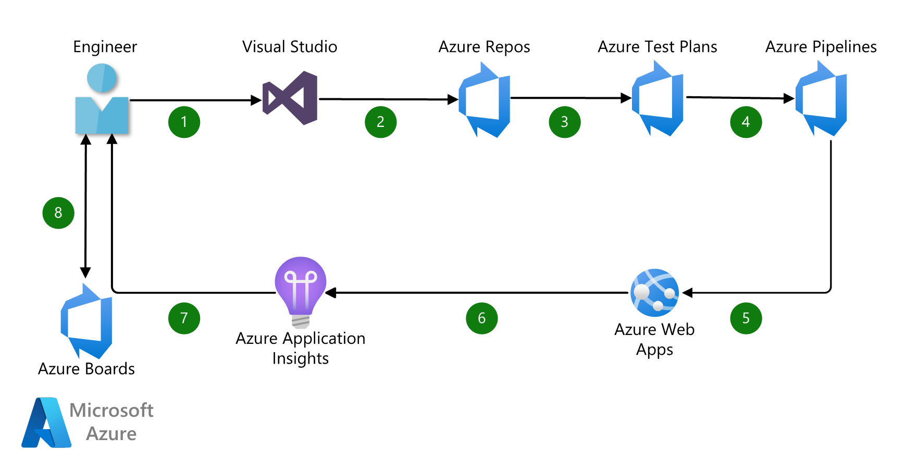

Figure 19: Azure Deployment Architecture (Microsoft Azure CI/CD documentation)

## The product

The demo of the product can be found here (insert URL). Some screenshots of the product can be seen in the following sections.

### Shelter Administrator Pages

Figure 20, Shelter Admin Dashboard: This is where a shelter worker updates their available bed count.

Figure 21, Shelter Admin Housing Features: This is where shelters can define the services they provide.

### Super Administrator Pages

Figure 22, SuperAdmin Dashboard: This is where the hosting organization can see cross-organizational statistics.

Figure 23, SuperAdmin Organization Management: This is where the Super Admin can onboard a new organization.

### Public and Navigator Views

Figure 24, Public Live Housing Feed: This is the landing page for anyone wanting to see availability in their city.

Figure 25, Housing Details: This is the pop-up information page to see what services each shelter provides.

# Conclusion and Future Work

To continue working towards our goal to reduce homelessness and develop this project we are aiming to form a nonprofit organization. Uvic Coast Capital Innovation Center is one of the centers we are hoping to get guidance and assistance from to form this non-profit. The vision of the organization is to reduce homelessness by providing platforms, which non-profit organizations could use to connect and their customers.

While exploring the complexity of the project given to us, we identified other areas in the social non-profit sector with problems waiting to be solved. Different shelters have different needs, but the one thing they all have in common is being largely overlooked by the tech industry. Much of their systems run on pens, paper, and endless hours of phone calls or emails. Our interviews with staff and clients lead us to multiple designs that could help streamline a support worker’s day job and hopefully lead to less burnout.

Primarily, an automated-waitlist service could be built for mixed-use shelters (homeless shelters) that would improve efficiency for the staff and provide bed availability at your fingertips through a mobile device to the public. We’ve already received feedback on some early designs that have come back positive. Secondly, a client management system for staff members of women’s shelters that helps them get up to speed quickly on what their client’s next steps are and what forms they’re currently working on. Given enough time and funding, we could potentially create an automated form-filling process that allows women to select and apply to multiple forms at once without having to repeat the same information over and over again. Finally, an anonymous distress app that lets individuals find a safe couch within their social network when attempting to flee a dangerous situation.

All of these ideas are simply prototypes still needing design validation, but the important takeaway is that there is no shortage of potential improvements when it comes to helping the social sector help ourselves with the problems we face on a local level. Our intention to address this is to found a non-profit tech company right here in Victoria Bc and get started on churning out solutions. We don’t have an official name yet, so for now, *Tek 4 Change* is a working title and we’re looking into government and philanthropic funding. Our vision is to create a software platform that brings together every social support service we have in Victoria, then scale out to other cities. A modular platform could be created that allows organizations to select the features they need to operate and collaborate with other nonprofits.

We’ve included below some images related to our main project that illustrates our User Experience (UX) and User Interface (UI) design process.

[THE FINAL UI SCREENSHOTS]

Uvic Coast Capital Innovation Center is one of the centers we are hoping to get guidance and assistance from to form this non-profit.

# Conclusion

As a result of our four-month involvement with Inspire, the Indigenous community on Vancouver Island, and shelters, we gained a deeper understanding of the challenges faced by people in need. As a result of our product, we believe we will enhance the quality of life and extend the life expectancy of those in need by providing them with valuable resources and information. This project can be improved and developed to support more people in need and provide them with a higher quality of support. To increase the capabilities of the existing work under a non-profit organization, we plan to develop Android and iOS mobile applications. Our goal is to form a not-for-profit organization that can provide technical support for the main website and mobile applications. We intend to tackle this matter on a grander scale.

# References

[1] P. A. Rollinson and J. T. Pardeck, Homelessness in rural America: policy and practice. New York: Haworth Press, 2006.

[2] L. Bryant, *Critical and creative research methodologies in social work*. Farnham, Surrey: Ashgate, 2015.

[3] K. Locharoenrat, *Research methodologies for beginners*. Singapore: Pan Stanford Publishing, 2017.

[4] K. Hacker, *Community-based participatory research*. London: SAGE Publications Ltd, 2017.

[5] S. S. Coughlin, S. A. Smith, and M. E. Fernández, *Handbook of community-based participatory research*. 2017.